`
County
Commissioners

Carolina Mejia - District One

Gary Edwards - District Two

Tye Menser - District Three
County
Manager
Ramiro Chavez
News
Release
Creating Solutions for Our Future
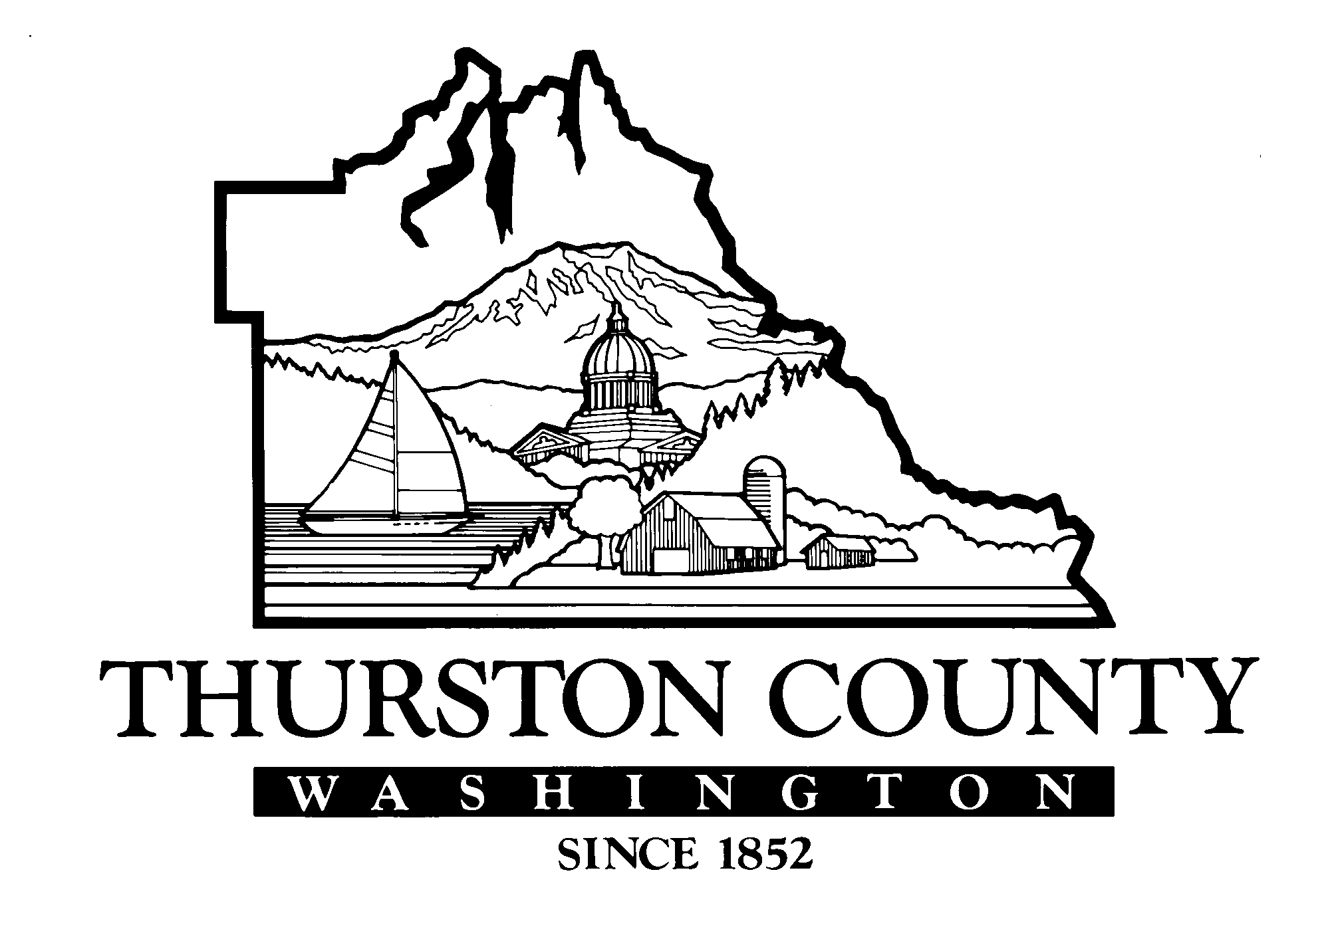

FOR IMMEDIATE RELEASE: Thursday, February 24, 2022

CONTACT: Ramiro Chavez, County Manager, 360-754-2960 or email at Ramiro.chavez@co.thurston.wa.gov
Mary Hall, Thurston County Auditor, 360-786-5224 or email at Mary.Hall@co.thurston.wa.us

County Suspends Contract with Community Action Council of Lewis, Mason, and Thurston Counties
The contract suspension was due to audit findings of suspected fraud in rental assistance payments

OLYMPIA – Yesterday, Wednesday, February 23, 2022, the Board of County Commissioners, after an executive session, voted to authorize the county manager to exercise the suspension clause of the contracts between Thurston County and Community Action Council of Lewis, Mason, and Thurston Counties (CACLMT) effectively immediately, and until further notice. The county manager sent the proper notification to CACLMT today suspending all contracts.

Thurston County has reported to the State Auditor’s Office suspected fraud in rental assistance payments managed by the CACLMT.

The county passes federal and state funds to the CACLMT to provide COVID-19 emergency rental and utility assistance. The Auditor’s Office conducted regular subrecipient monitoring of the emergency rental assistance distributed by the CACLMT.

The county found a sample of four applications totaling more than $86,000 that indicated potential fraud by the applicants. An additional two applications had been placed on hold by the CACLMT pending requests for more information. The county is taking the next steps to determine the magnitude of the potential fraud as well as working through the process to recover those funds.

“We have strong internal controls that caught these questioned payments in the course of regular subrecipient monitoring,” said Mary Hall, Thurston County Auditor. “This is an example of the audit process working.”

Hall chairs the county’s Internal Audit Committee, which also includes Thurston County Treasurer, Jeff Gadman, and County Manager, Ramiro Chavez.

“We take fraud seriously,” Treasurer Gadman said. “Protecting public resources is the highest priority for Thurston County and is why we develop robust internal controls.”

-MORE-

“It is important to note that this was discovered even during a period when we were quickly responding to the impacts of the pandemic on our community,” Chavez said. “Even in extraordinary times, the accountability, and check and balance culture at Thurston County is effective.”

Chavez added, “While this may cause a brief delay in rental and utility assistance funds for our community members, we are working as quickly as we can to have a system in place to continue to provide services to those in need.”

-30-

